Bowling ball out and back challenge Name:
Color & mass of ball (kg) |  |  | Date: |  |  | Period:
Length (tiles)
 | Start/stop area | Pushing area | Coasting area |  | Pushing area | Turn around area
Length (m)
- Out: Push the ball with the broom in the first m, then you can’t touch it for the next m. In the final m, push it to slow it down so you can turn it around once you enter the turn zone.
  - You have about one meter of turn zone in which you can turn the ball around. The ball cannot cross the line at the back of the turn zone.
- Back: You then push to turn the ball around, and repeat these steps for the path back to the start.
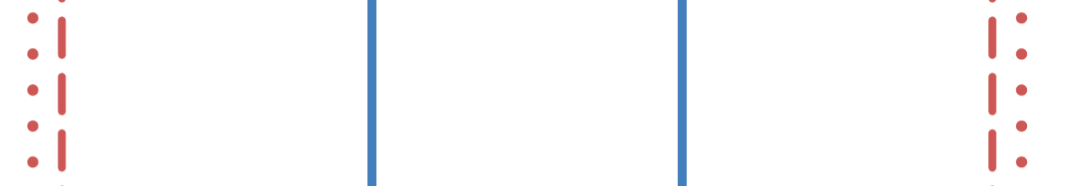
  - You have another meter of start/finish zone in which the ball must stop.
Turn zone
Coasting area
Pushing area
Pushing area
Start/finish

Outbound trip  time (s) | Departed  (should be zero) | Crossed first line |  | Crossed second line |  | Arrived
Return trip  time (s) | Arrived | Crossed first line |  | Crossed second line |  | Departed
Out | Calculations → and result | Acceleration (m/s/s) (assume v_{i} = 0) | Velocity (m/s)  Hint: Solve this before accelerations |  | Acceleration (m/s/s) (assume v_{f} = 0) | ← Calculations and result
 | Calculations → and result | Force (N) | Force (N) |  | Force (N) | ← Calculations and result
Back | Calculations → and result | Acceleration (m/s/s) (assume v_{i} = 0) | Velocity (m/s)  Hint: Solve this before accelerations |  | Acceleration (m/s/s) (assume v_{f} = 0) | ← Calculations and result
 | Calculations → and result | Force (N) | Force (N) |  | Force (N) | ← Calculations and result
Bowling ball circle challenge Name: Period:
Sketch of your circle and pit stop area. Label the radius. |  | Color and mass of ball  (kg)
Circle radius
(m)
Time
(s)
Circumference  (m) show calculation |  | Velocity (m/s) show calculations
Centripetal acceleration
(m/s/s) show calculation
Centripetal force
(N) show calculation

